Simulation of OCO Algorithm
Over
OMNET++

Table of Contents:

p.2: Directories in OCO algorithm code
p.3: Files involved in OCO algorithm simulation
p.6: Illustration of OCO Simulation Steps



University of Houston Clear Lake
Directories in OCO algorithm code (Zip file) are as follows:

Fig 1: 1st Level of OCO Code directories architecture

Fig 2: 2nd Level of OCO Code directories architecture

Fig 3: 3rd Level of OCO Code directories architecture

Files involved in OCO algorithm simulation:

- Pos_Collection Directory (3rd level):

- Pos_Collection.exe: This is the executable file we run to start the position collection simulation.
- test.ned: This file is used to model the Processing phase simulation.
- test_n.cc: All the .cc extension files are used to define the working of different modules in sensor network according to the OCO processing phase algorithm.
- omnetpp.ini: This file is used to initialize the application.

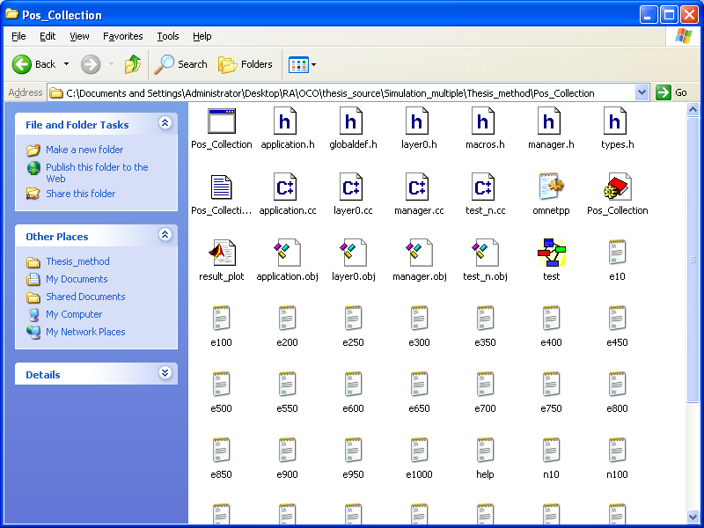
Fig 4: Screenshot of files in the Pos_collection directory

- Shortest Directory (3rd level):

- Shortest.exe: This is the executable file we run to start the tracking phase simulation.
- test.ned: This file is used to model the Processing phase simulation.
- test_n.cc: All the .cc extension files are used to define the working of different modules in sensor network according to the OCO processing phase algorithm.
- omnetpp.ini: This file is used to initialize the application.

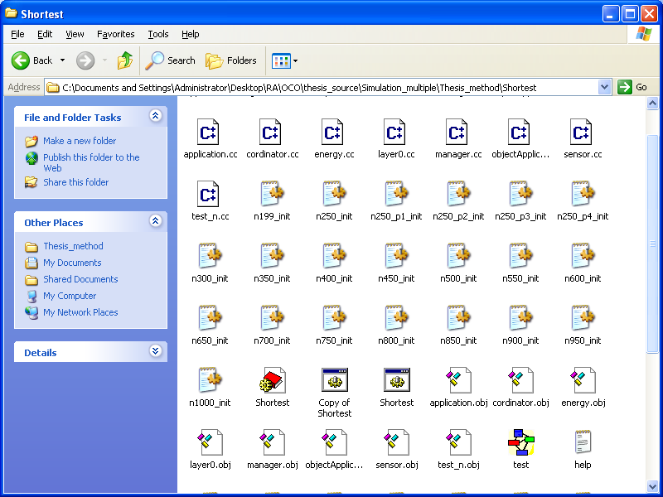
Fig 5: Screenshot of files in the shortest directory

- WSN_O_Track Directory (1st level):

- WSN_O_Track.exe: This is the executable file we run to start the processing phase simulation.

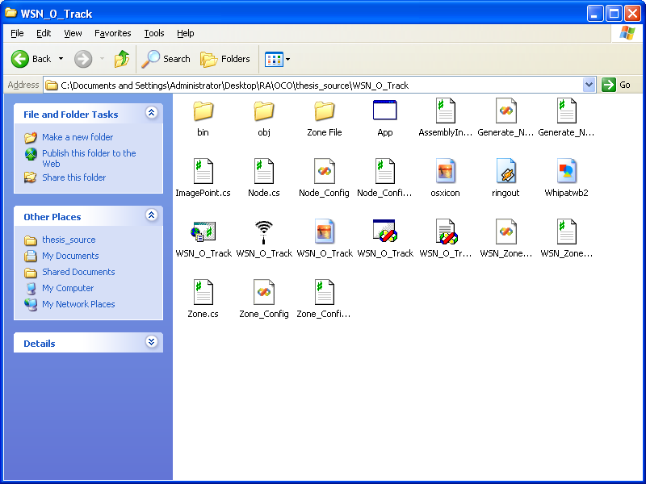
Fig 6: Screenshot of files in the WSN_O_Track directory

OCO Algorithm Simulation Steps:
1. Position Collection Phase:
- Run the Position_Collection.exe file to start the simulation.
- Assign the parameters for WSN as shown in fig.7
- Click on the run button fig. 8 of the generated tknev GUI to run the simulation.

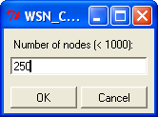
Fig 7: Screenshot of Position Collection phase (select the number of nodes)

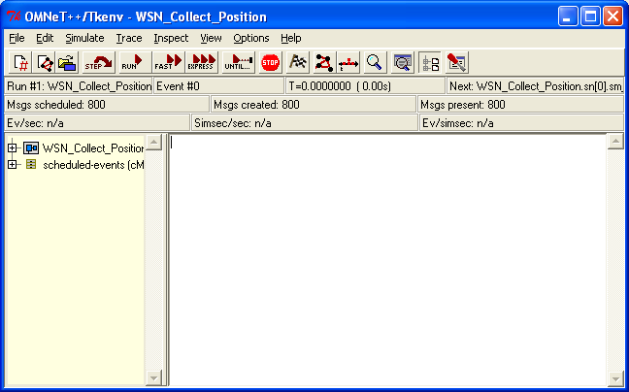
Fig 8: Screenshot Tkenv application window to start the simulation

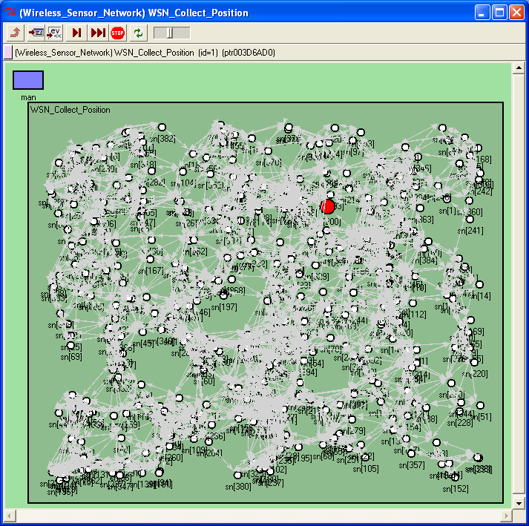
Fig 9: Screenshot of OCO position collection phase (showing the WSN after running the simulation

Result: After this simulation step two text files are generated naming n_(no. of nodes) (as shown in fig. 10 defining the corresponding x-y position of each node) and e_(no. of nodes) (as shown in fig. 11 defining energy level of each node after the processing phase simulation) in the working directory. We will use the n_(no. of nodes) (as shown in fig. 11) file in further simulation.

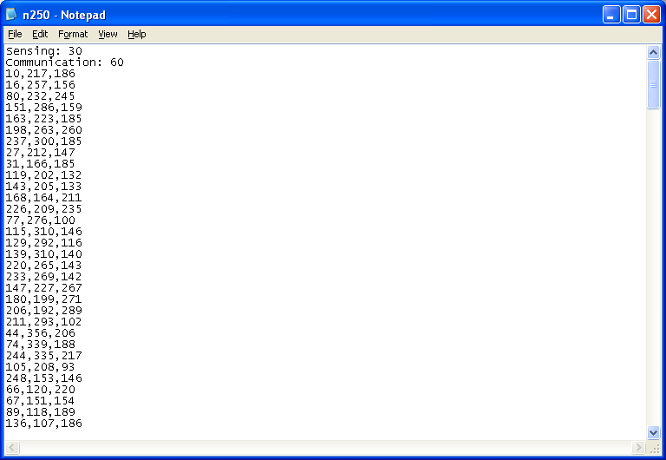
Fig 10: Screenshot of OCO position collection phase (showing the content of the file n250, which consists of information such as sensing radius, communication range, and the x-y coordinates of the nodes)

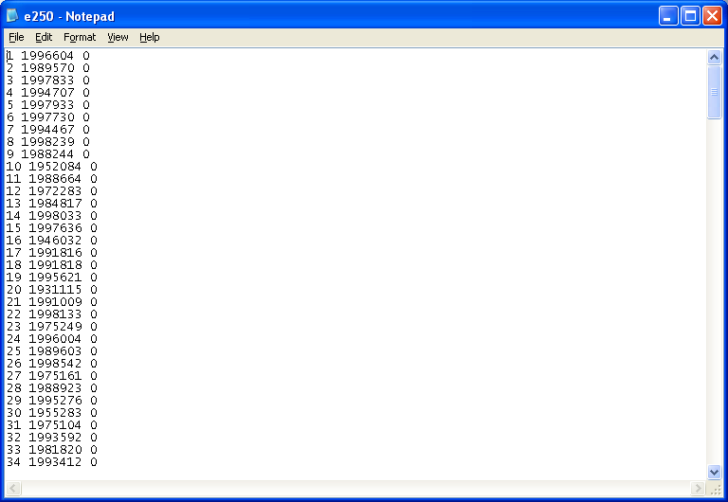
Fig 11: Screenshot of OCO position collection phase (showing the energy level of the nodes

2. Processing Phase:
- Run the WSN_O_Track.exe to start the processing phase simulation.
(Location: WSN_O_Track->bin->debug->WSN_O_Track.exe) file to start the simulation.
- Import the n_(no. of nodes) file by going to the file menu as shown in fig. 12
- Run the processing phase by going to the Tool menu of the application window.

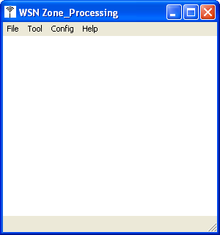
Fig 12: Screenshot of OCO processing phase application window

Result: After the completion of processing phase simulation four .ini (ex. n199_p1_init, n199_p2_init, n199_p3_init, n199_p4_init) extension files are generated according to the four predefined path of intruder object in Matlab file (draw_path.m) for the WSN network. Export the results to the one of these methods for the next tracking phase simulation:

- Simulation_standby->Thesis_method->Shortest: (For no intruder condition)
- Simulation_single->Thesis_method->Shortest: (For single intruder condition)
- Simulation_multiple->Thesis_method->Shortest:(For multiple intruder condition)

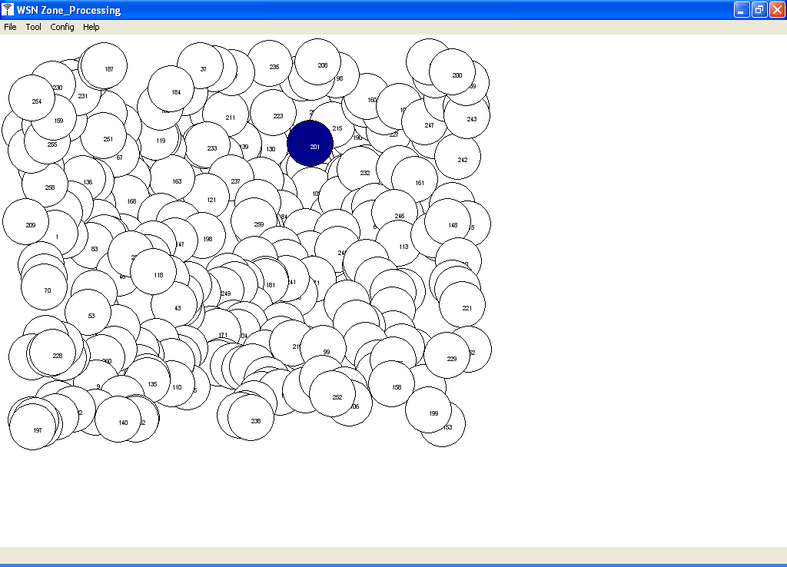

Fig 13: Screenshot of OCO processing phase application window (showing the processed image of WSN after running the simulation, where dark blue node indicates the base node of WSN)

3. Tracking Phase:
- Run the shortest.exe –f .ini file (ex. n199_p1_init) imported from the processing phase file to start the tracking phase simulation.

- Click on the run button of the generated tknev GUI to run the simulation.

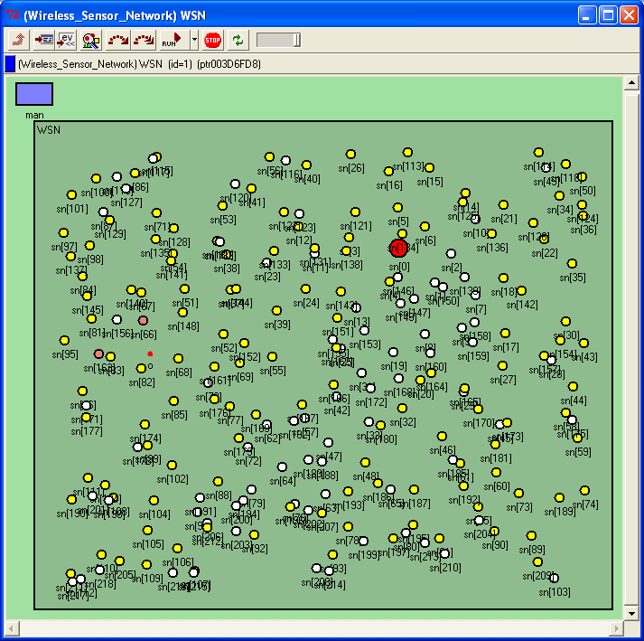
Fig 14: Screenshot of OCO tracking phase simulation (showing the base node, all border nodes, forwarding nodes and the intruder object in WSN)

Result: After this simulation step resultant text files are generated naming in the directory mentioned in the .ini file. These results can be used further to draw the graphs and analyze the simulation.

- A Matlab program file result_plot.m is available in results directory under each simulation type (stand by, simulation_single, simulation_multiple).
- Go to the directory of resultant text file and copy the Matlab program result_plot.m in that folder.
- The function textread will read the data from the resultant file and draw the graphs for various parameters.

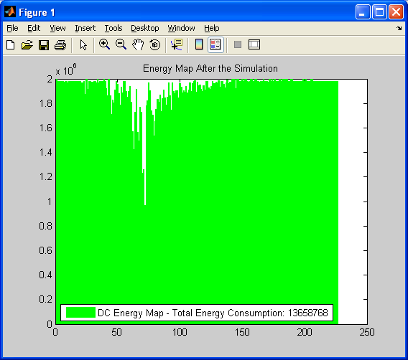
Fig 15: Screenshot of OCO tracking phase simulation result over Matlab (showing the energy level of each node after the simulation for target tracking)

X-axis: Number of nodes
Y-axis: Energy remaining (in Jules) after the simulation
The above graph shows the energy level of each sensor node after the target tracking phase. The initial energy was 2×10^6 Jules. It also shows the total energy consumption in the network.

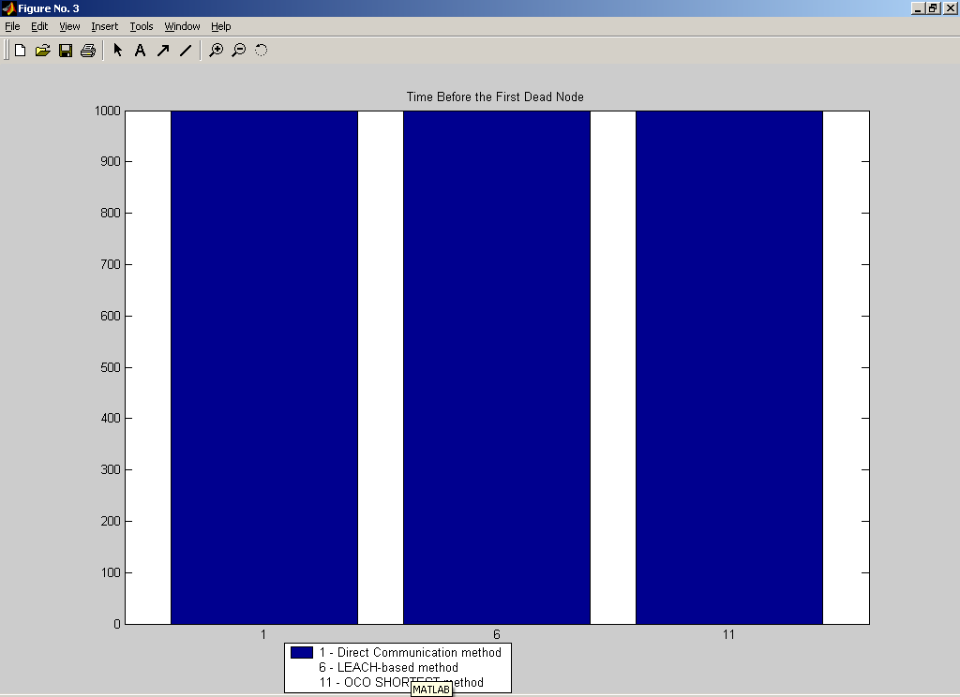
Fig 16: Screenshot of OCO tracking phase simulation result over Matlab(showing the time before the first dead node in comparison with DC and LEACH methods)

X-axis: Type of methods (DC/LEACH/OCO)
Y-axis: Time (in seconds) before the first dead node appears
This figure shows that there is no dead node after the target tracking phase simulation in the WSN consisting of 250 nodes.

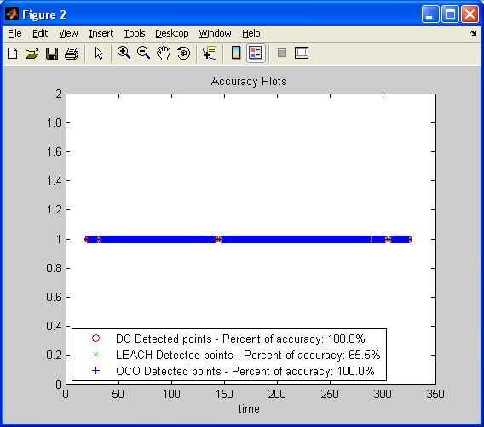
Fig 17: Screenshot of OCO tracking phase simulation result over Matlab (showing the accuracy of intrusion detection in comparison with DC and LEACH methods)

X-axis: Time of detection
Y-axis: Accuracy
This figure shows that the accuracy of target detection in DC method and OCO method is 100% in case of 250 sensor nodes WSN with single intrusion. The accuracy of each method is a percent ratio between the number of detected points of the method and the standard number of detected point.

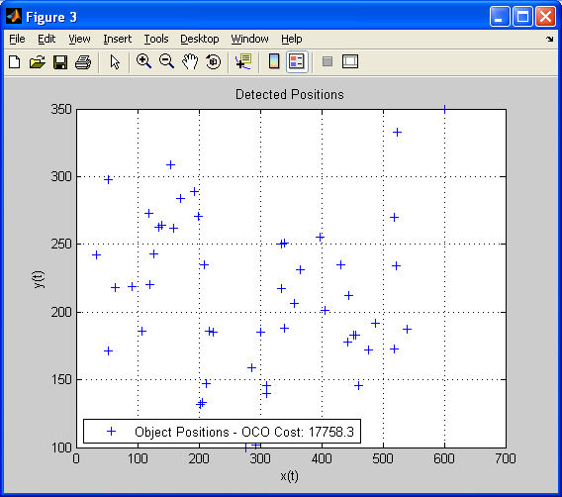
Fig 18: Screenshot of OCO tracking phase simulation result over Matlab (showing the x-y position of detected objects during the tracking phase, and the cost of detection )

X-axis: The X coordinates of the intruder object’s position
Y-axis: The Y coordinates of the intruder object’s position
This figure shows that the cost of OCO method for 250 nodes and single intrusion scenario is 17758.3. Cost per detected point is a ratio between the total energy consumption and the total number of detected points of the method.

